Соотнесите слово с картинкой и определением. Затем назовите королевство, к которому относится этот предмет одежды.
The word | Picture | The definition | The name of the part of the country
Kilt | 1) 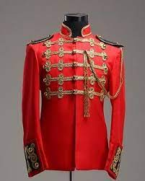 | a) a leather sling bag | ?
«Chimney sweep hat» | 2) 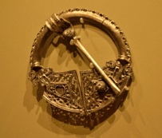 | b) a long shirt | ?
Double skirt | 3) 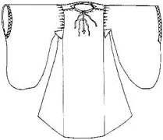 | c) a thick piece of cloth wrapped around the hips | ?
Mutch | 4) 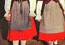 | d) a cap with lace | ?
Sporran | 5) 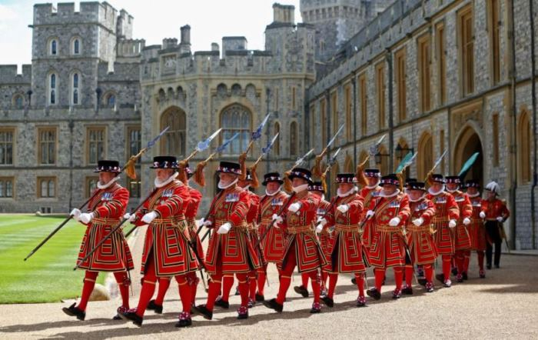 | e) a woolen Irish cloak | ?
Barmoral | 6) 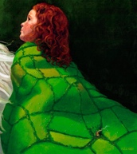 | f) a wool beret with red pompom and two silk ribbons | ?
Bret | 7) 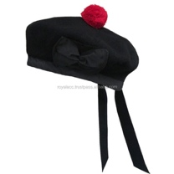 | g) a flanel skirt and a wool skirt | ?
Black bowler | 8) 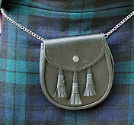 | h) a brooch that secures the cloak | ?
Lane | 9) 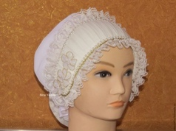 | i) men's military or court jacket | ?
High stockings | 10) 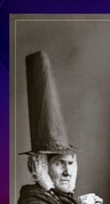 | j) a black cap that Tower Guards wear | ?
Red Camisole | 11) 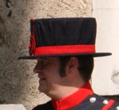 | k) a high top hat | ?
Fibula | 12) 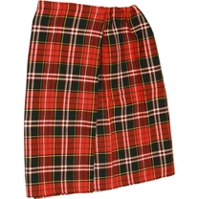 | l) high long socks | ?

Scotland:
Kilt - a thick piece of cloth wrapped around the hips

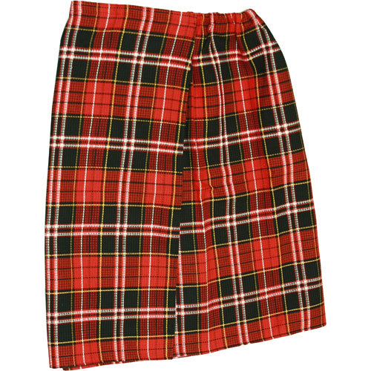

Sporran – a leather sling bag
Barmoral – a wool beret with red pompom and two silk ribbons
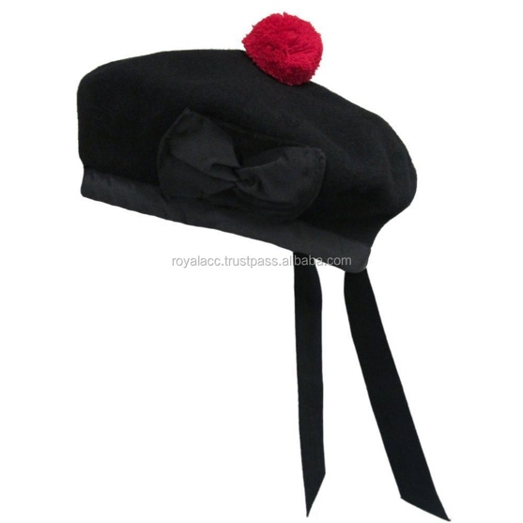

Wales:
Double skirt – a flanel skirt and a wool skirt

Mutch – a cap with lace
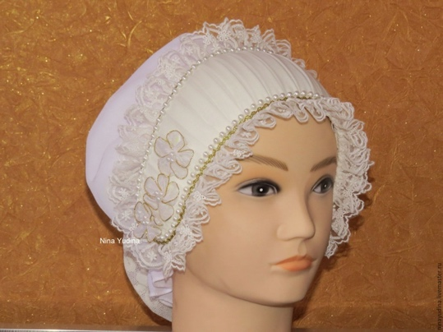

«Chimney sweep hat» - a high top hat

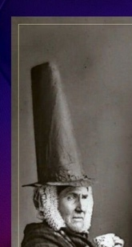

Northern Ireland:
Lane – a long shirt
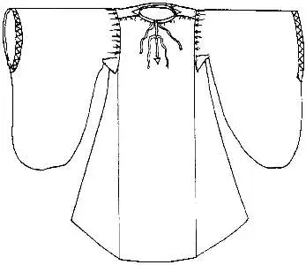

Bret – a woolen Irish cloak
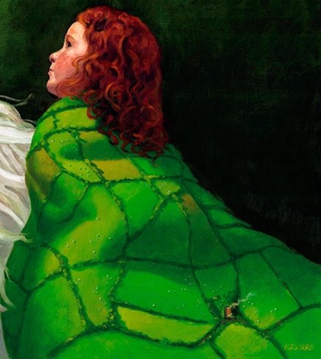
Fibula – a brooch that secures the cloak
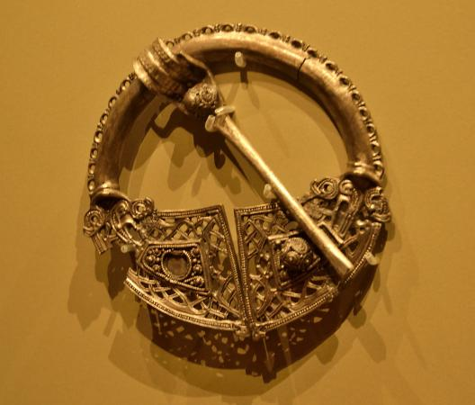

England:
Red camisole - men's military or court jacket

High stockings – high long socks

Black bowler – a black cap that Tower Guards wear

