London Tower

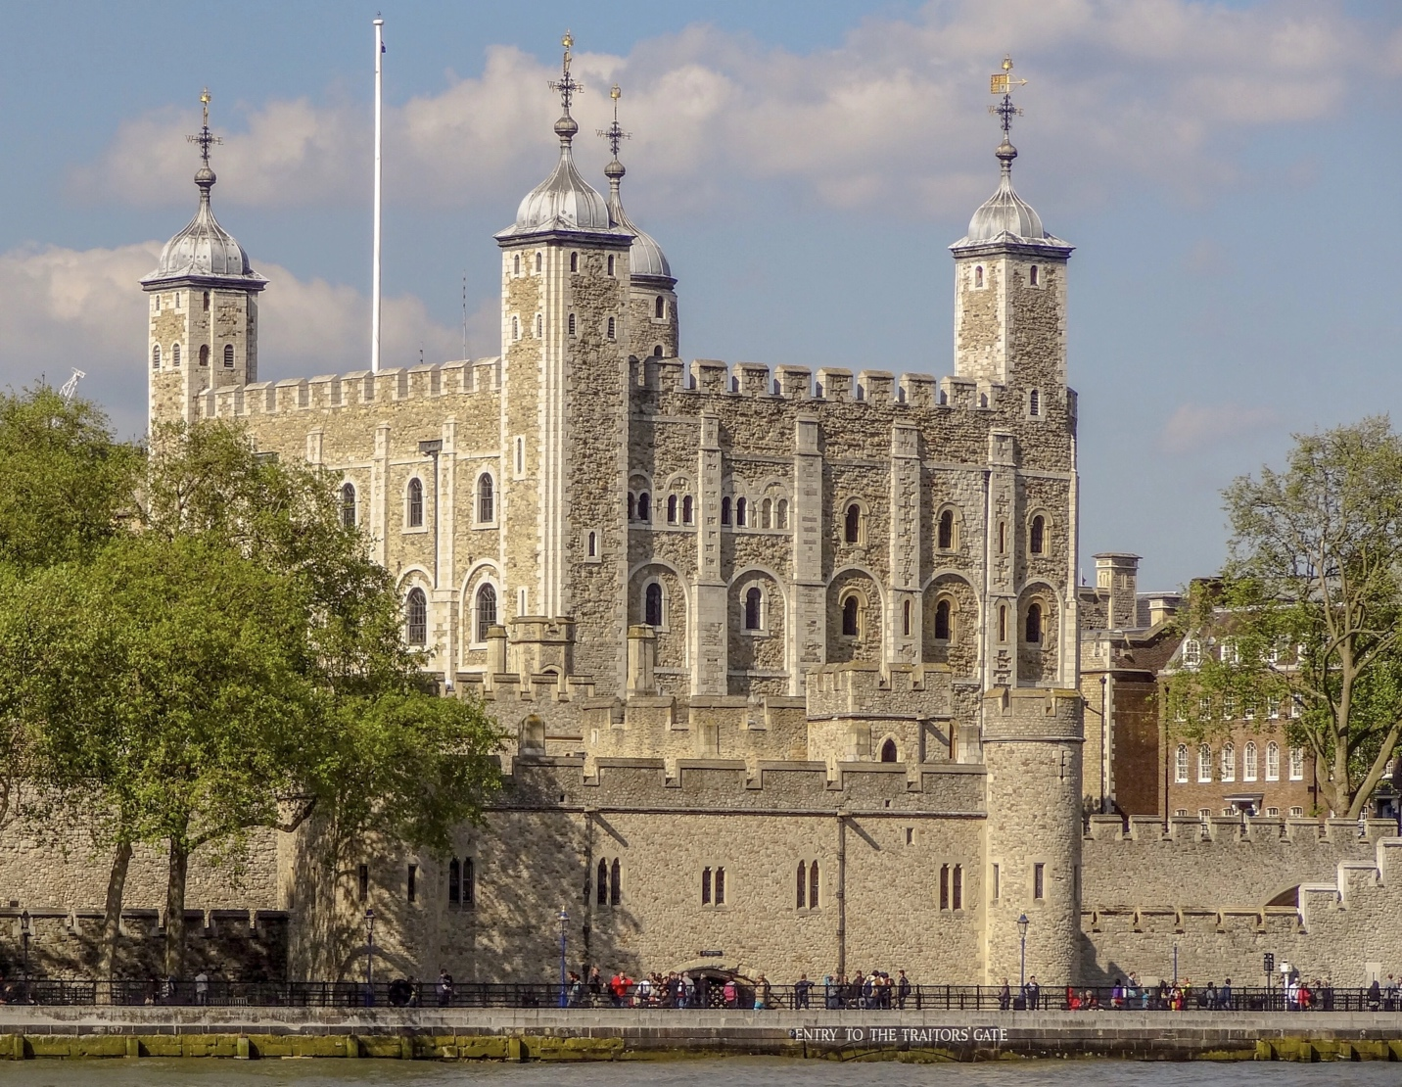

The Tower is a fortress built in 1078. It stands on the north bank of the Thames. It is one of the oldest buildings in England and the historic centre of London. Initially, it was built as a defensive castle, and then it served as a zoo, and a mint, and an arsenal, and a prison, and an observatory, and a repository of royal jewels.
Big Ben
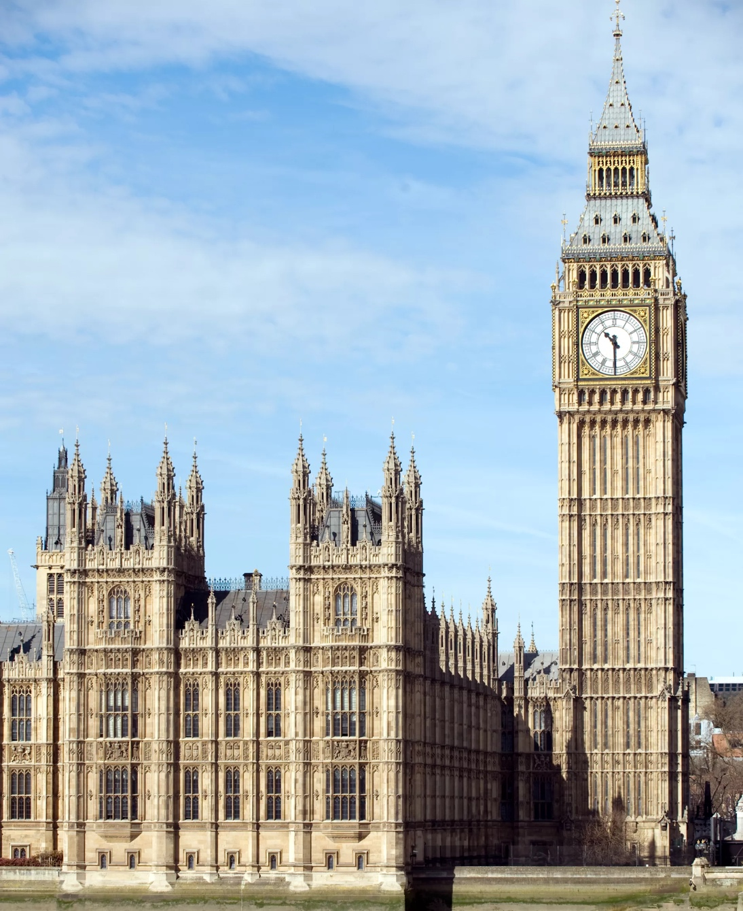

The height of the tower is 96 meters, inside it hides a narrow spiral staircase of 334 steps. The clock was put into action on May 21, 1859. Four dials are made with a Latin inscription, which means "God save our Queen Victoria". Officially, the new year on Earth begins with the first impact of Big Ben.
Tower Bridge

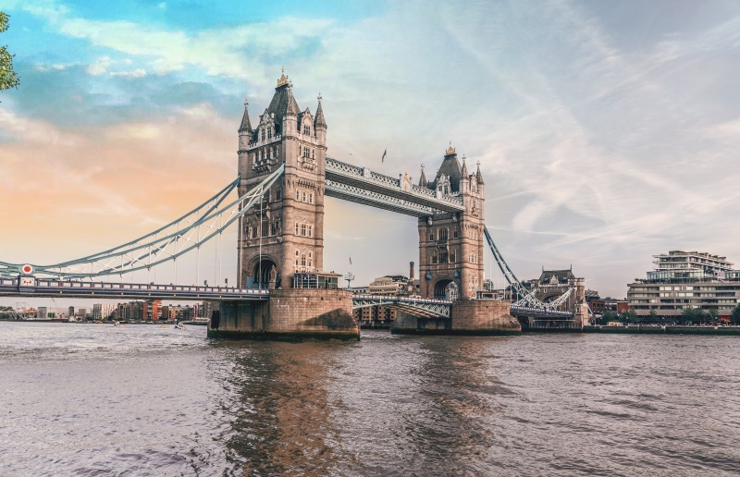

Tower Bridge was opened in 1894. It is both adjustable and hanging. When the lower central bay is opened for the passage of ships, the upper gallery, which is reached by stairs in both towers, remains open for pedestrians wishing to cross the Thames. Tower Bridge is 244 meters long. The height of the two supporting towers is 65 meters.

London Eye

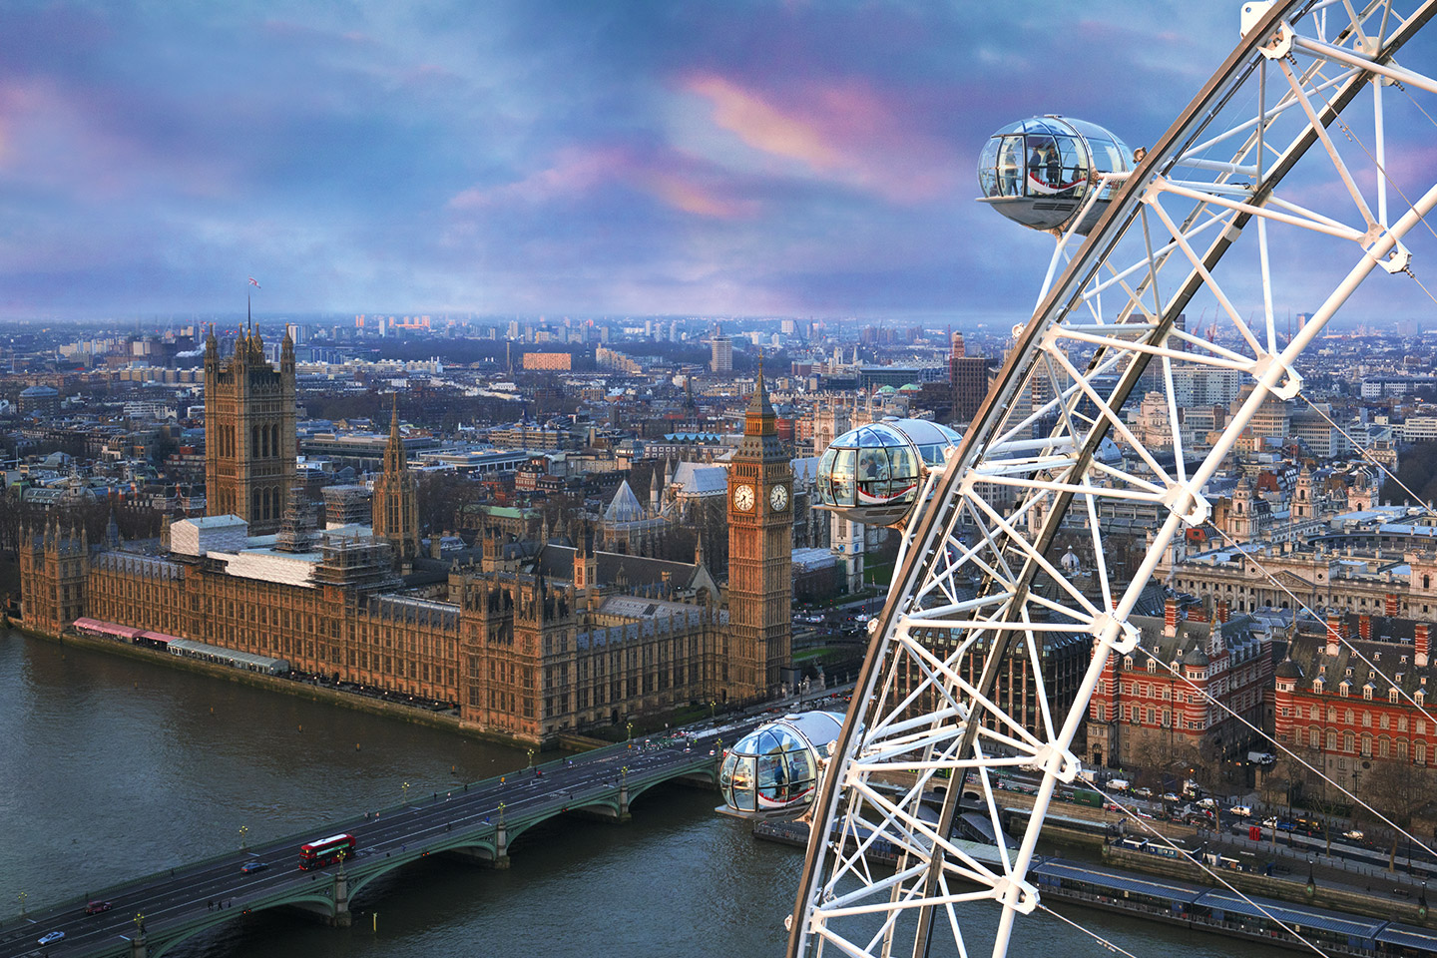

The London Eye is a ferris wheel built for the Millennium celebration. Its height is 135 meters from the base. The London Eye has 32 transparent cabin capsules, each of which can accommodate up to 25 people. The wheel makes a complete revolution in 30 minutes.

Buckingham Palace
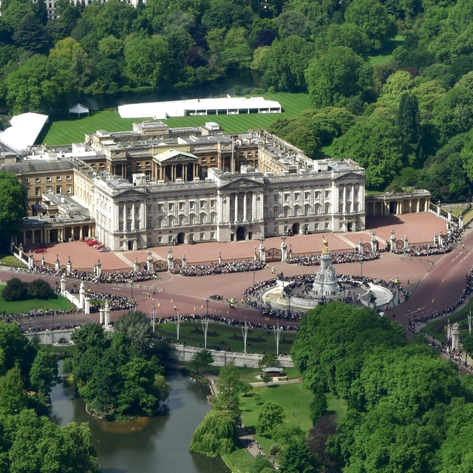

This is the official residence of His Majesty the King in London. The palace has 775 rooms. Initially, the palace was built for the Duke of Buckingham. Upon accession to the throne of Queen Victoria in 1837, it was declared the main residence of the British monarchs.

Trafalgar Square

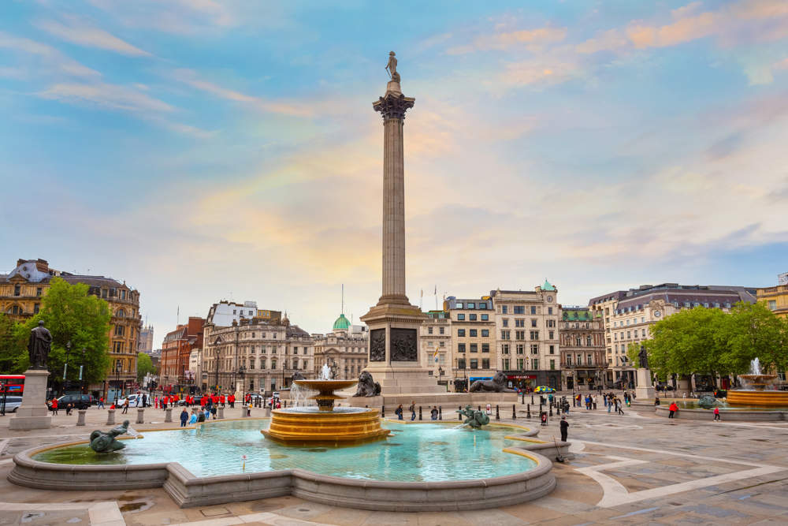

The square was named after the victory of the British fleet under the command of Admiral Nelson at Trafalgar in 1805. In the middle of the square a column crowned with the figure of Admiral Nelson stands. There are also the London National Gallery, St. Martin's Church, Admiralty Arch.

