- The legendary leader of the Britons of the 5th-6th centuries, who defeated the Saxon conquerors; the central hero of the British epic and numerous romances of chivalry. Until now, historians have not found evidence of its historical existence, although many admit the existence of its historical prototype.

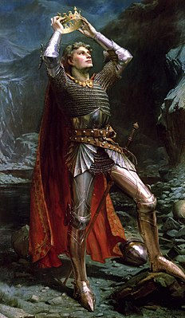

- The famous English poet and playwright was recognized as the greatest writer in the world. Perhaps it would be a bold act to call him a symbol of the culture of the United Kingdom, but it was his huge collection of sonnets, comedies, tragedies and other works that made a huge contribution to the history of the English people. He created bright characters endowed with mighty will and strong passions.

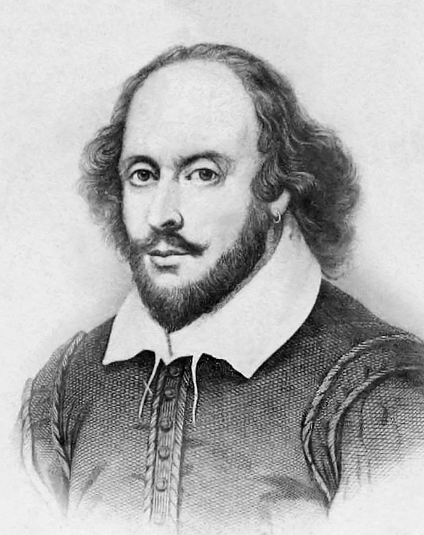

- He proved that the movements of objects on Earth, as well as celestial bodies in space, obey the same natural laws by demonstrating the correspondence between Kepler's laws of planetary motion and his theory of gravity. Thus, he eliminated the last doubts about heliocentrism. His monograph is considered to be one of the most important scientific works ever written, due in part to the style of the book itself, which has helped to set the standard for scientific publications up to the present. In addition, he built the first reflecting telescope and developed a color theory based on observing how a prism decomposes white light into many colors that form the visible spectrum.

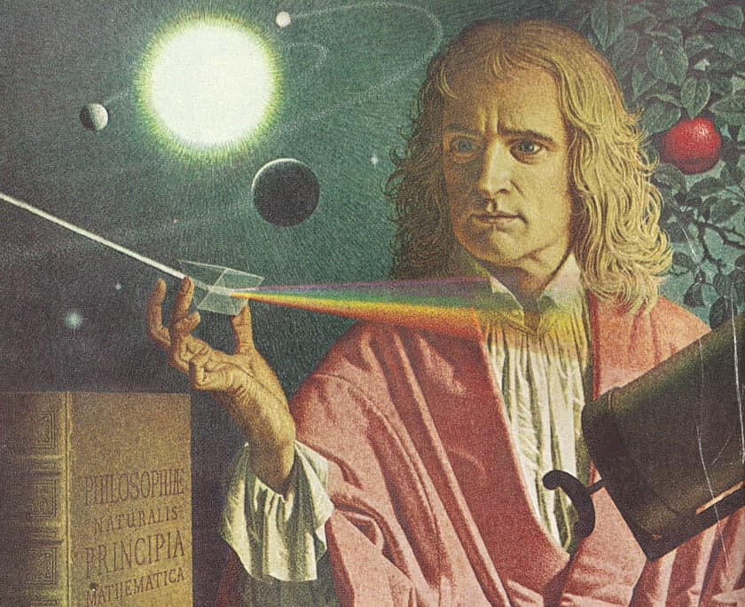

- The English "queen of detectives" left behind a huge collection of priceless manuscripts, which were read by more than one million readers. Her name is listed in the Guinness Book of Records - she is the best-selling writer of detective stories of all time. The writer's books have sold over 2 billion copies and have been translated into 100 languages.

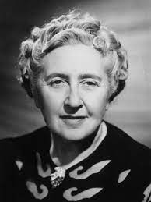

- The famous Hollywood beauty, actress and model went through a difficult life path and, having overcome depression and numerous complexes, received world recognition, the highest statuses and the love of millions. The actress is raising several adopted children and is helping third world countries with all her might, for which she deservedly bears the title of Goodwill Ambassador of the Office of the United Nations High Commissioner for Refugees.

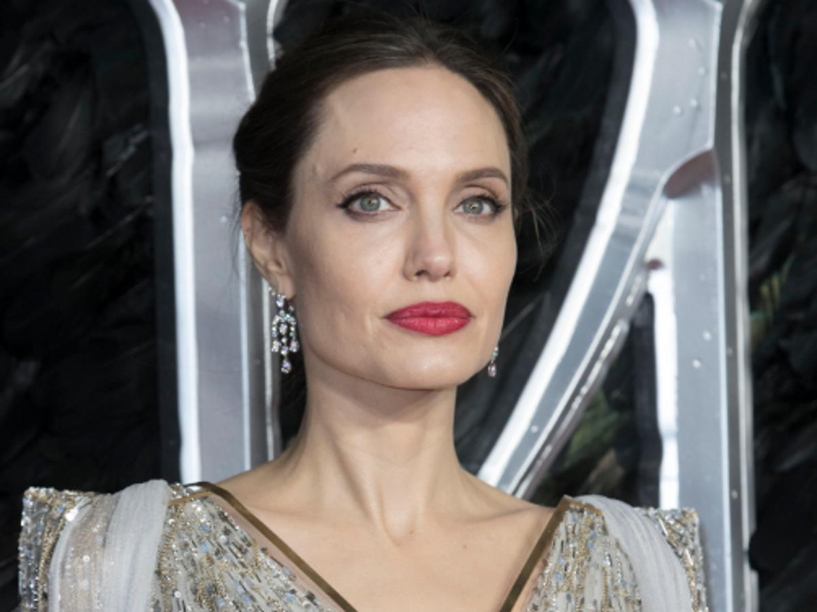

- The world-famous Scottish writer, poet and historian made an invaluable contribution to the development of world fiction. Through his works, one can get to know Scotland and the life of its inhabitants, each of them is a literary masterpiece that touches the hearts of millions of readers to this day.

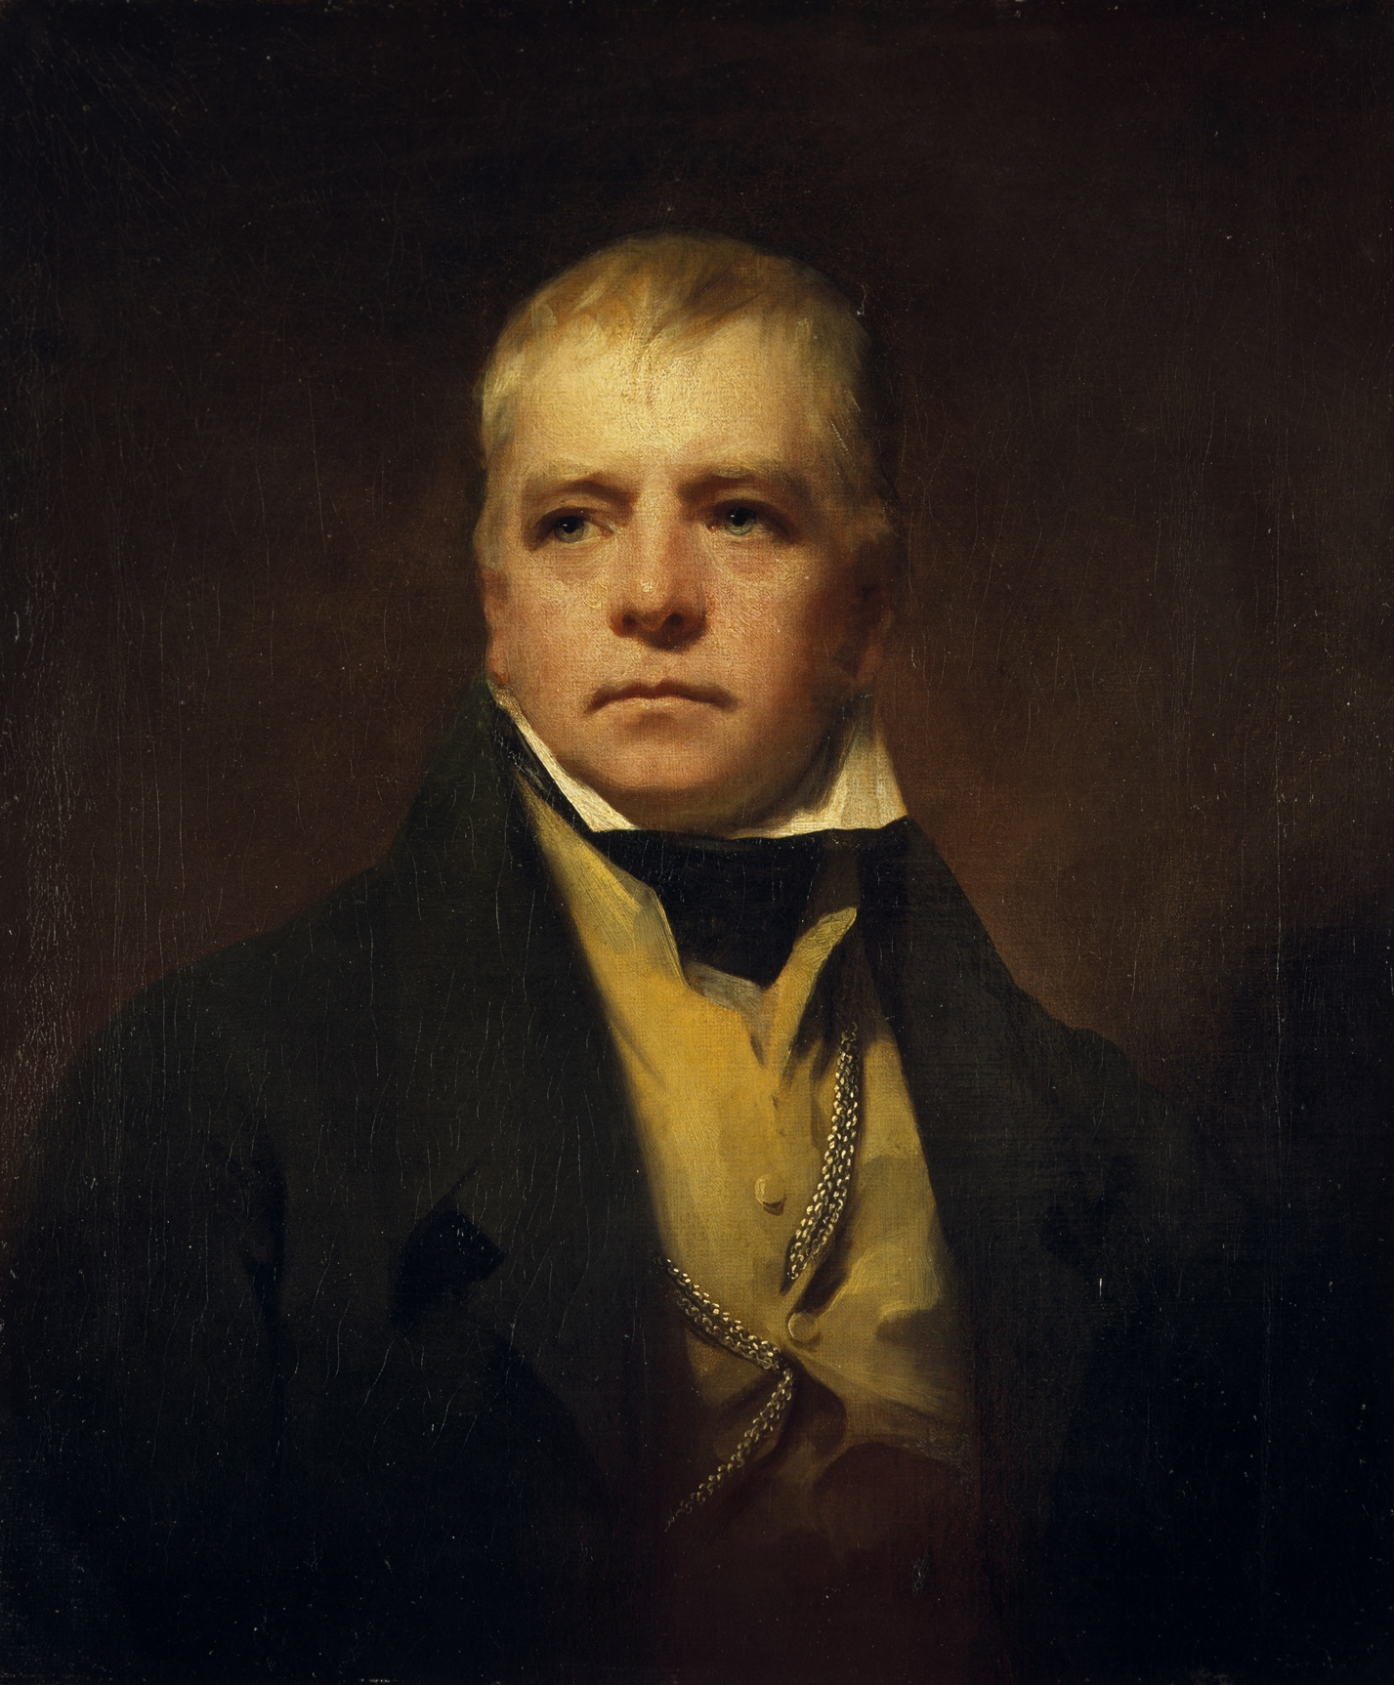

- English writer and journalist, whose novel "Robinson Crusoe" brought worldwide fame. He is notable for being one of the early adepts of the novel genre, helping to popularize it in the UK, and many researchers call him one of the founders of the English novel. He created more than five hundred works on various topics, was a pioneer in the genre of economic journalism.

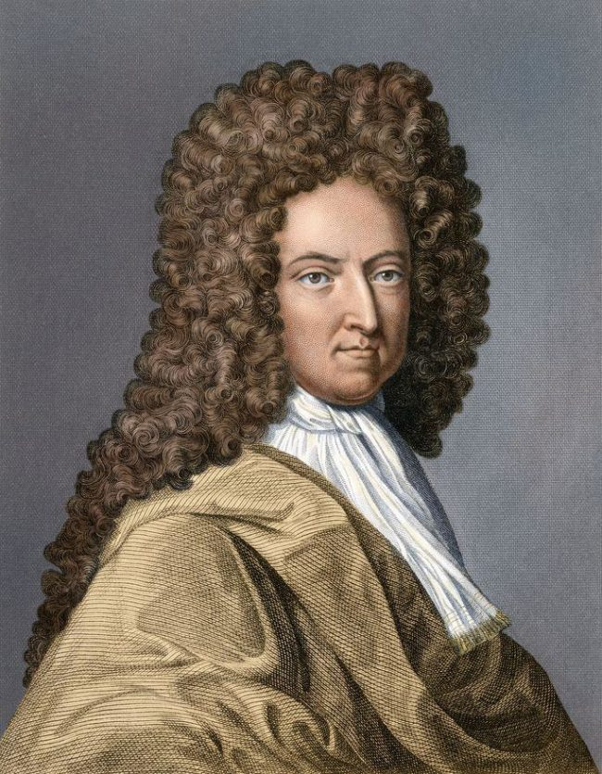

- He was an English rock musician, singer, artist, writer and peace activist who gained worldwide recognition as a founding member of the Beatles and the de facto leader of the group. Paul McCartney and our hero made up the most successful songwriting duo in rock and roll history. He showed the world his rebellious nature and natural intelligence in such films as "A Hard Days Night", the books "In His Own Write" and "A Spaniard in the Works".

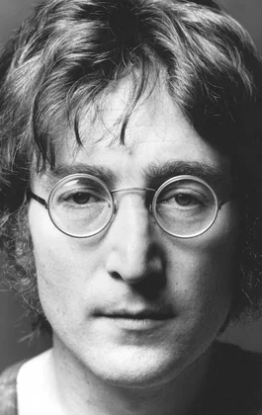

- First wife of Prince Charles. The couple's sons, Princes William and Harry, are the second and third in line of England's heirs respectively. Having become, after her engagement to Prince Charles, a public figure, she remained in the center of constant attention of the British and world press even after the divorce; even her death is associated with excessive paparazzi attention. The car accident that killed the princess caused literally mass mourning.

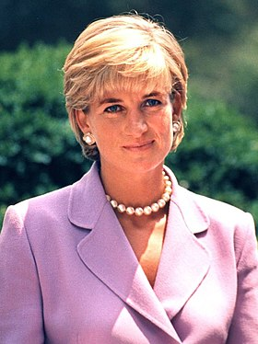

- MBE is an English footballer who currently plays for Los Angeles Galaxy and the English national team. He is rented for two months by the Italian club AC Milan, so that the football player can keep his form during the "dead season". After the England match against France on March 26, 2008, he received his famous golden baseball cap.

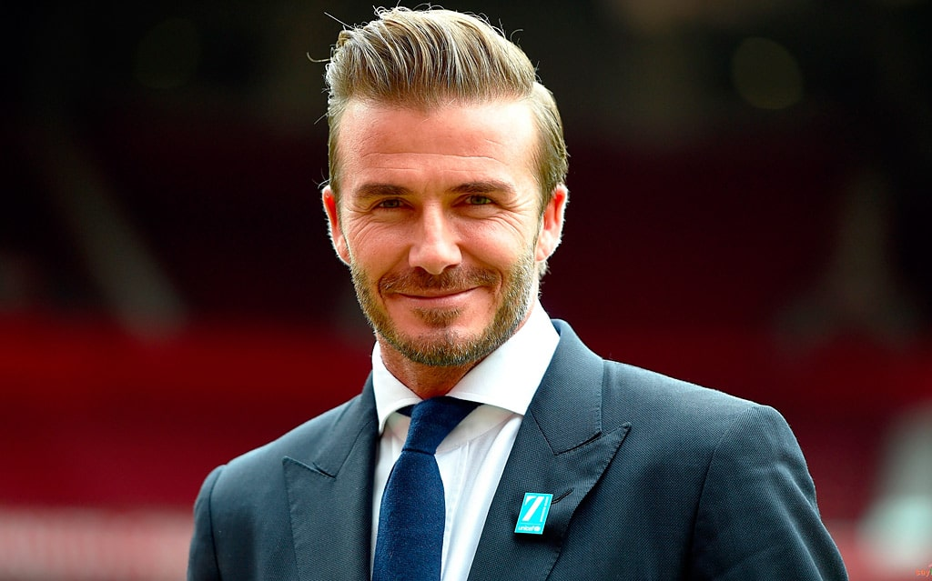

- This Englishwoman was born on January 9, 1982 in the city of Reading. Her family never belonged to the English nobility. But now she is seriously considered by many residents of the British Isles as the future Queen of England.

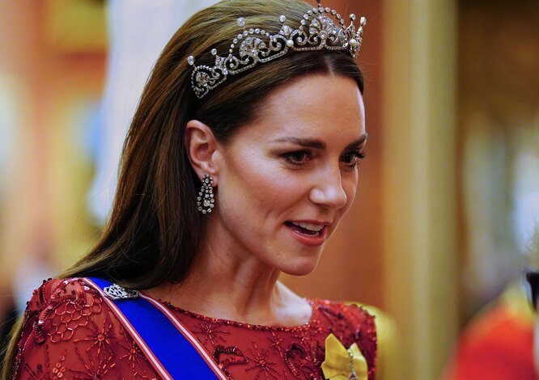

- She is called the "English rose": the actress, who played the role of Rose in the legendary "Titanic", received two BAFTA awards for her contribution to world cinema, an Oscar for her role in the film "The Reader" and two Golden Globe Awards. According to the designer of cars "Jaguar", it was she who became the source of inspiration for him when developing the Jaguar XK model - after all, she is a real Briton, open and talented, with an attractive appearance and a rich inner world.

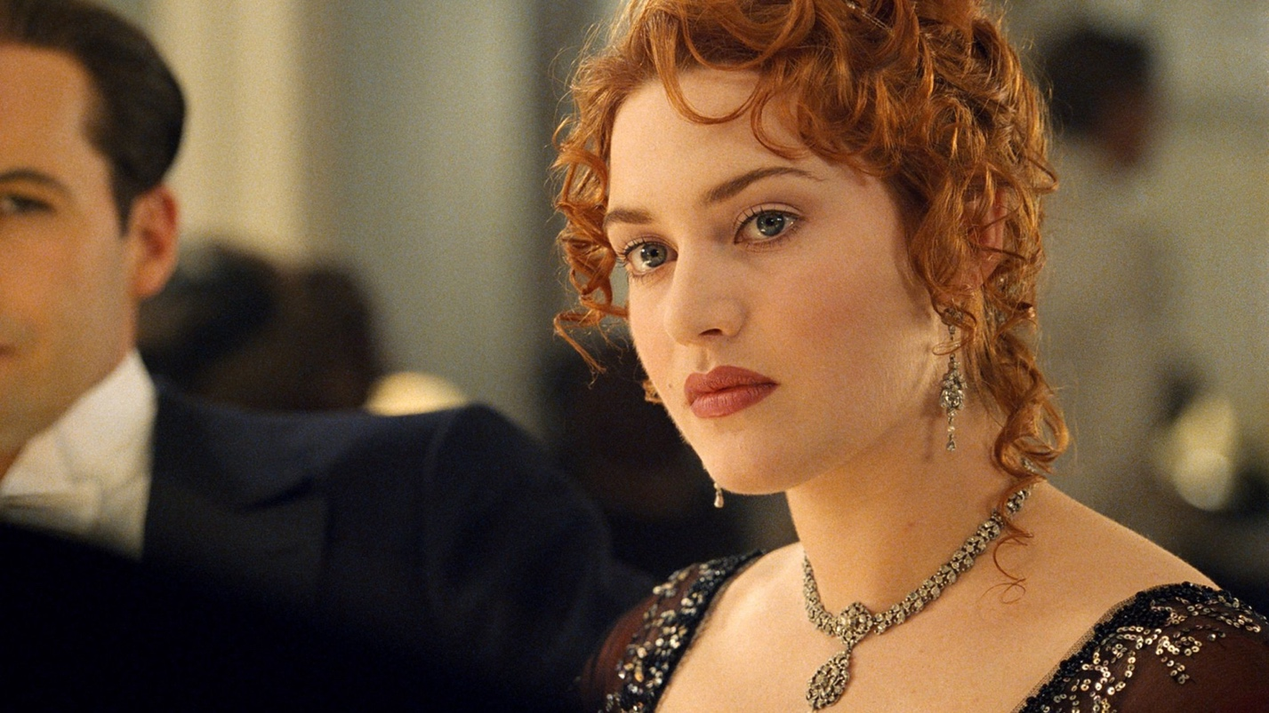

- The author of famous works about Sherlock Holmes and Dr. Watson was not going to become a writer. He graduated from the University of Edinburgh and began to practice medicine, but his works were such a success with the general public that he soon left medicine and devoted himself entirely to literature. Contemporaries did not consider him a serious writer, but now he is a classic of British literature.

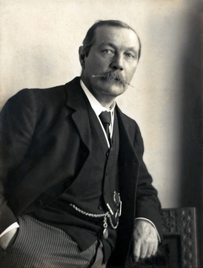

- English writer, mathematician, logician and photographer. His most famous works are the stories "Alice in Wonderland" and "Alice Through the Looking-Glass", as well as the poem "The Hunt for the Snark" and the poem "Jabberwocky", written in the genre of literary absurdity. The ease with which he played with words and fantasized entertained both children and the literary elite, influencing the work of many writers.

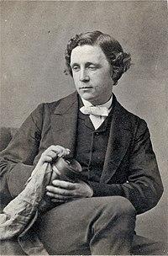

- One of the brightest pop stars, singer, actress and director, who has been at the peak of popularity for more than twenty years and is an idol for millions. In addition to an incredibly successful musical career, she acts in films, writes books, does charity work and raises children. Despite the ambiguous attitude of the press, she can safely be called the best English-speaking singer of the late 20th century.

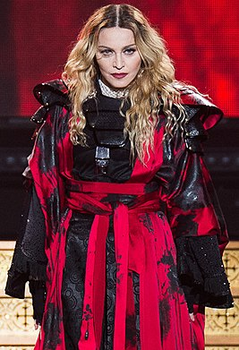

- The English poet, writer and essayist was one of the most famous playwrights of the Victorian period. All his life he opposed public opinion, and saw the only refuge from vulgarity, boredom and monotonous monotony in art. The memory of this amazing man, who was not afraid to surprise, has not subsided to this day. According to The Telegraph newspaper, he surpassed Shakespeare and Winston Churchill in wit.

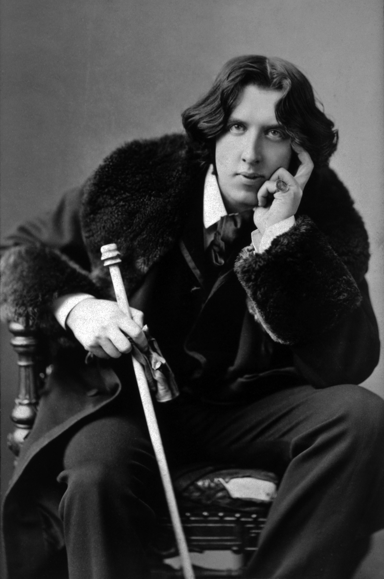

- He got into the Guinness Book of Records as the most successful musician and composer in the history of popular music - 60 of his albums went gold. "Yesterday" also made it there as the most covered song with over 3,700 covers and 7 million plays on US radio and television. "Mull of Kintyre" (1977) became the first single to sell over 2 million copies in the UK.

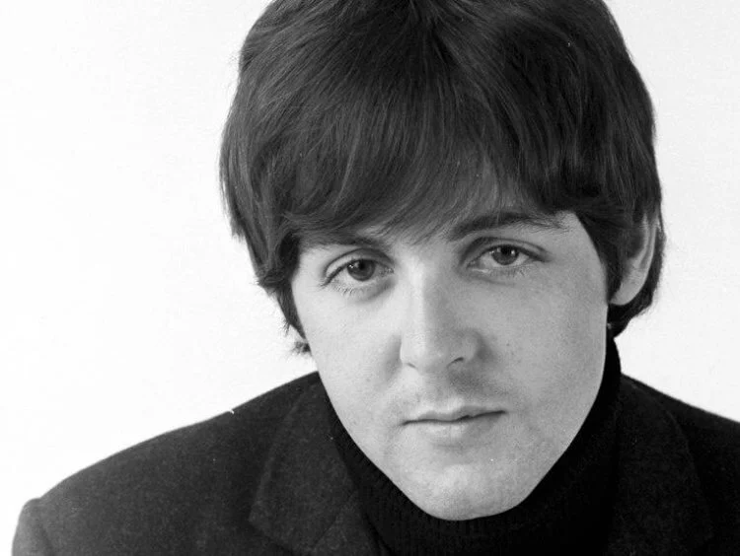

- He was the grandson of the seventh Duke of Marlborough, that is, a direct descendant of the first Duke of Marlborough. However, he did not have the title of duke, since according to English tradition, the noble title is inherited by the eldest son in the family, and his father was the second son. If his own uncle had no sons, then he would definitely have become the ninth Duke of Marlborough, but then he would not have taken the chair of the Prime Minister of Great Britain.

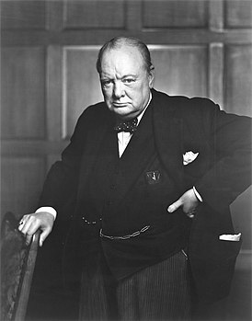

- The English writer and prose writer acquired the status of a genius of fiction during his lifetime. Any of his works is a special school of life, his works are imbued with deep meaning, he created a special world into which he let both children and adults in with ease and great joy. The prose of this talented writer is distinguished by subtle wit, which was later called "English humor".

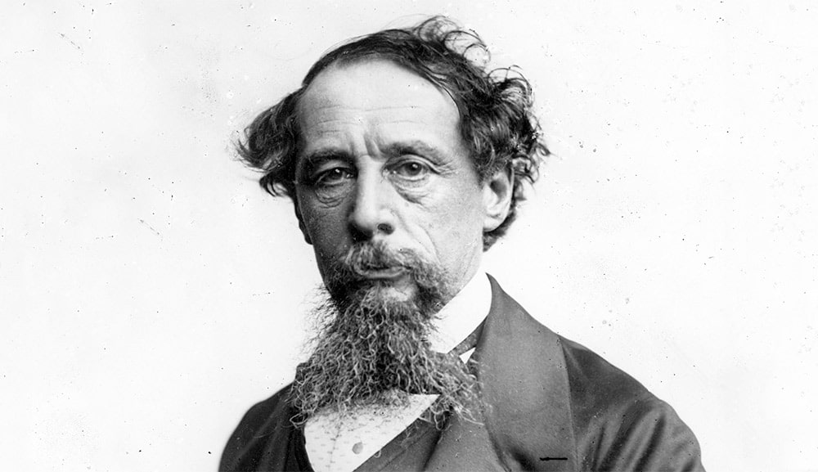

- He was born in the city of Glasgow. The boy's parents were the owners of a grocery store. As a child, he attended St. Andrew's School, which at the age of 13 he was forced to leave and start earning money in order to financially help his parents while studying at night school. In 1864 he went to the USA to work. In 1870, the young man returned to Glasgow, where he opened his first store, Lipton Market, which began to make a profit.

